Department of Computer Science and Engineering (Data Science)
CSDS-A | Batch A6 (CSE - Data Science, Section A)
ClauseGuard: Legal Contract Complexity and Predatory Clause Detector
(ClauseGuard)
S.No. | Student name | Roll / hall ticket no.
1 | CH.PRANATHI | 23K91A6744
2 | G.PRANAVI | 23K91A6762
3 | G.CHARAN JOSEPH | 23K91A6753
4 | G.BHAGWATH | 23K91A6760
Under the guidance of: [GUIDE NAME], [DESIGNATION]
BLOCK DIAGRAMS
This document collects every design diagram of ClauseGuard. Each diagram was drawn from the real code, database models and routes and is followed by a paragraph that explains it. The diagrams were generated by scripts/make_diagrams.py with matplotlib.
Table 1: Diagrams in this document
No. | Diagram | Shows
1 | System architecture | Browser, FastAPI routers and services, SQLite, local files, Gemini API
2 | High-level workflow | Ten steps from upload to report
3 | DFD level 0 | Context: ClauseGuard and its external entities
4 | DFD level 1 | Seven processes and five data stores
5 | DFD level 2 | Expansion of the clause-classification process
6 | Use-case diagram | Actors and their use cases
7 | Sequence diagram | Uploading a contract and reading the report
8 | ER diagram | Four database tables
9 | UML class diagram | Entities, rule model and services
10 | Algorithm flowcharts | process_upload() and classify_clause()

1 System Architecture
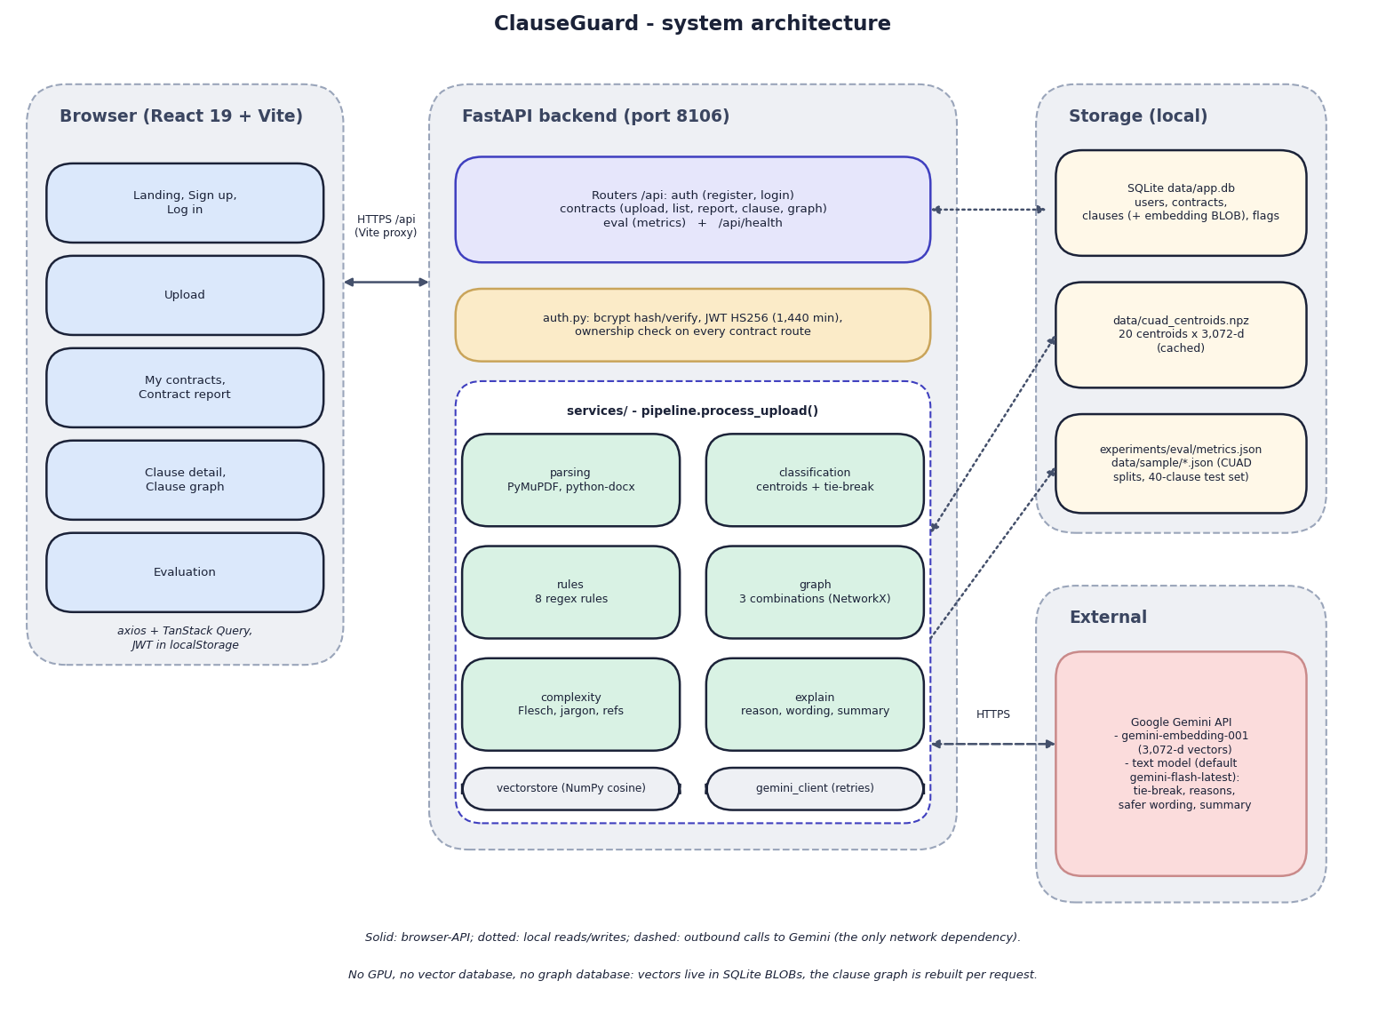
Fig. 1: System architecture of ClauseGuard
The diagram shows four zones. On the left is the browser: a React 19 single-page application built with Vite. Its pages are grouped as landing, sign-up and log-in; upload; my contracts and the contract report; clause detail and clause graph; and the evaluation page. The application talks to the server through Axios and TanStack Query, and it keeps the JSON Web Token in the browser's local storage. In development the Vite server on port 5106 proxies every /api call to the backend, so the browser sees one origin.
In the centre is the FastAPI backend on port 8106. A thin router layer (auth, contracts and eval, plus /api/health) validates requests; auth.py hashes passwords with bcrypt, signs HS256 tokens and is the dependency that identifies the caller, and every contract route checks that the contract belongs to that caller. Below it, pipeline.process_upload() orchestrates six services: parsing (PyMuPDF and python-docx), classification (centroids and an optional tie-break), the eight regular-expression rules, the NetworkX combination graph, the complexity score and the explanation service that writes the wording. Two helpers sit underneath: the NumPy cosine routines and the Gemini client with its retries.
On the right, local storage holds the SQLite file data/app.db (users, contracts, clauses with their embedding blobs, flags), the cached centroid file data/cuad_centroids.npz, and the JSON files that carry the CUAD splits, the 40-clause test set and the evaluation results. The only external dependency is the Google Gemini API, called over HTTPS for embeddings (gemini-embedding-001, 3,072 values per vector) and for text (tie-break, reasons, safer wording and summaries). The footnote of the figure states what the design does not contain: no vector database and no graph database.

2 High-Level Workflow
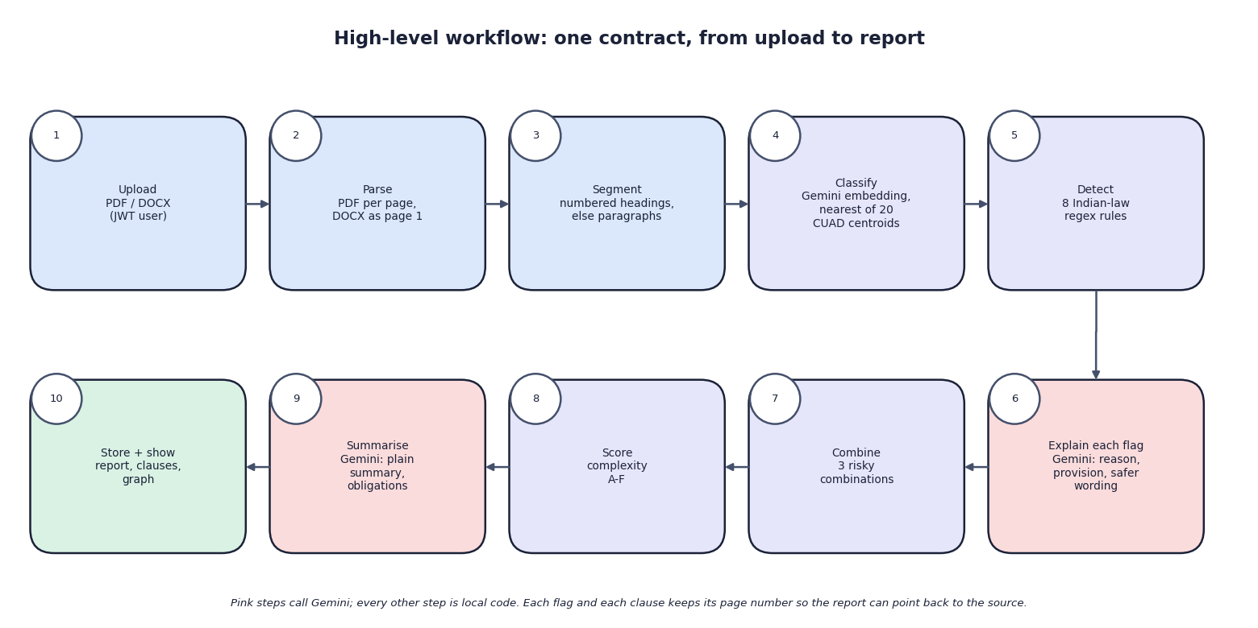
Fig. 2: High-level workflow
Ten steps take one contract from upload to report. A signed-in user uploads a PDF or DOCX (1); the file is parsed, page by page for a PDF and as a single page for a DOCX (2); each page is segmented at numbered headings or, failing that, at paragraphs (3). Each clause is then embedded and given the label of the nearest of 20 CUAD category centroids (4), and the eight Indian-law rules are tested on its text (5). Every rule hit is sent to Gemini together with the rule's legal basis, and the answer supplies the plain-language reason, the quoted provision and the safer wording (6). After the last clause, the risky combinations are looked up (7), the complexity score and grade are computed (8) and a second Gemini call writes the summary and the list of obligations (9). Everything is committed in one transaction and the report is shown (10).
The pink boxes are the steps that call Gemini (4, 6 and 9); every other step is local code. The decision that a clause is risky is made by step 5, never by Gemini. A failed Gemini call after three attempts stops the whole upload, and nothing is saved.

3 Data-Flow Diagram: Level 0
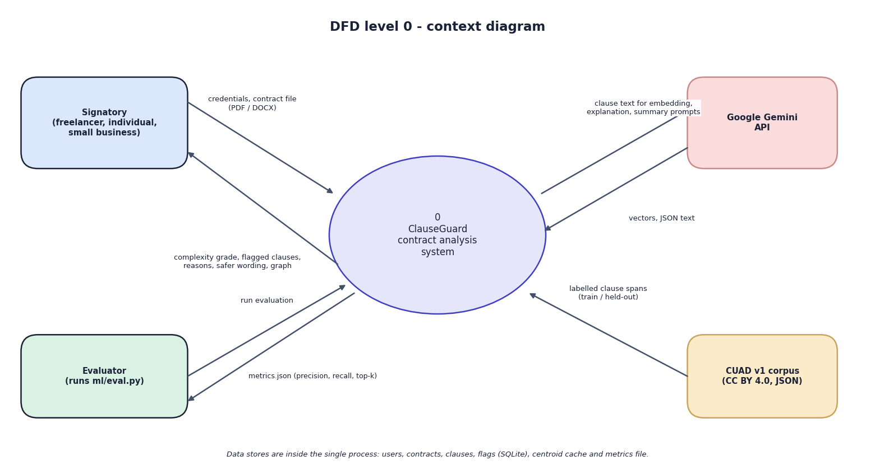
Fig. 3: Data-flow diagram, level 0 (context)
At the highest level ClauseGuard is one process with four external entities. The signatory, who may be a freelancer, an individual or a small business, sends credentials and a contract file and receives the complexity grade, the flagged clauses with reasons and safer wording, and the clause graph. Google Gemini receives clause text and prompts and returns vectors and JSON text. The evaluator, who is whoever runs ml/eval.py, starts an evaluation and receives metrics.json with the precision, recall and top-k scores; the CUAD v1 corpus supplies the labelled clause spans from which the training and held-out sets were drawn. The data stores are inside the single process and are not drawn at this level.

4 Data-Flow Diagram: Level 1
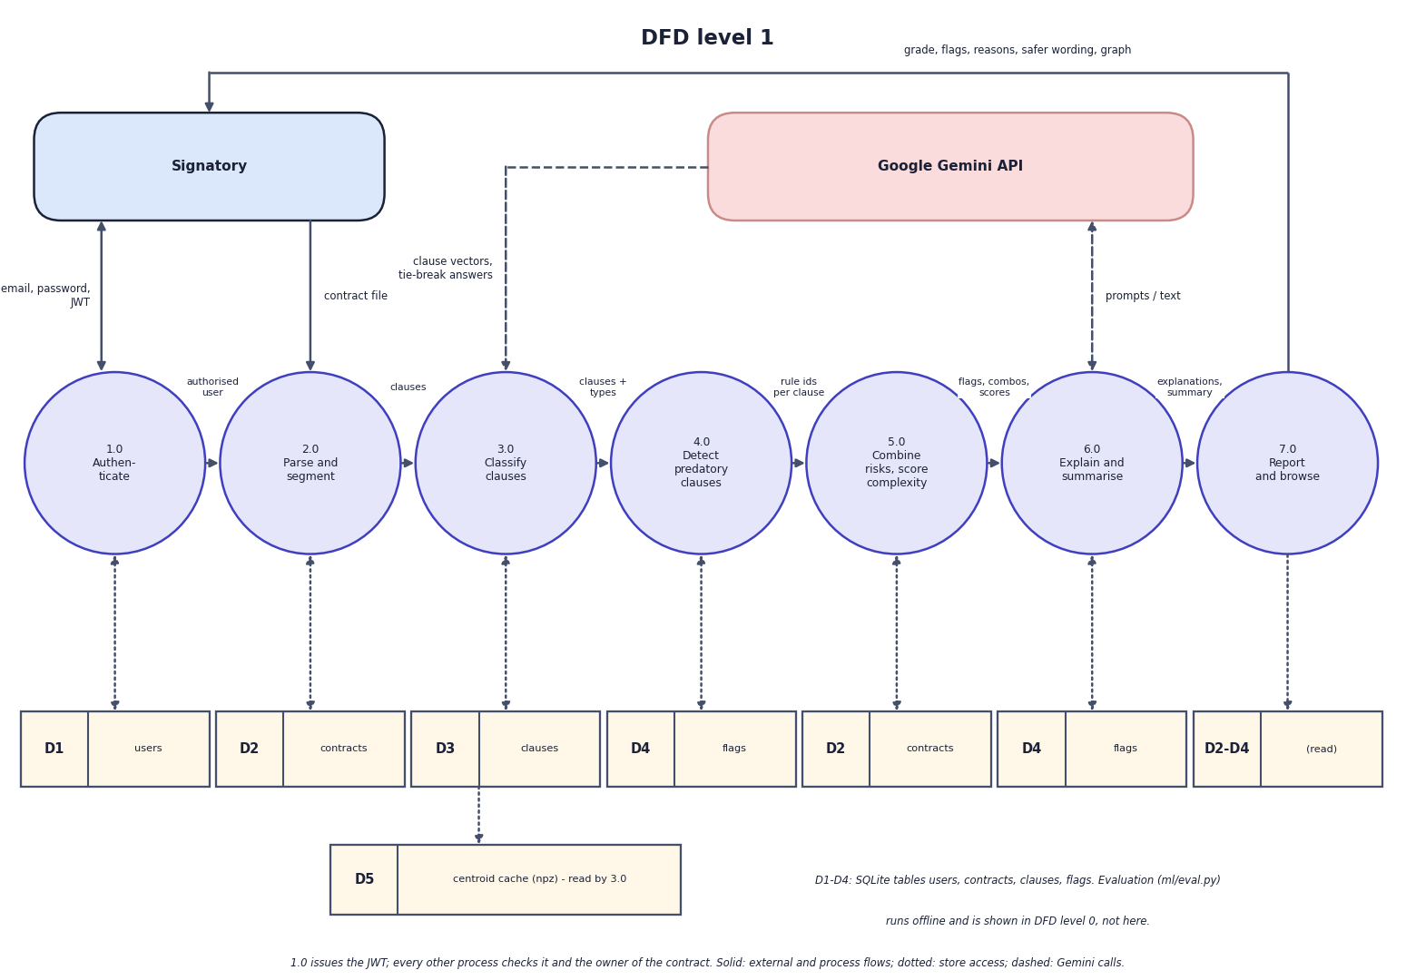
Fig. 4: Data-flow diagram, level 1
Level 1 splits the system into seven processes: authenticate (1.0), parse and segment (2.0), classify clauses (3.0), detect predatory clauses (4.0), combine risks and score complexity (5.0), explain and summarise (6.0), and report and browse (7.0). The stores are D1 users, D2 contracts, D3 clauses (with the embedding), D4 flags and D5 the centroid cache; D2 and D4 are drawn twice because two processes use each. Process 1.0 issues the token, and every later process checks it and the owner of the contract. Process 2.0 creates the contract row and produces clauses; 3.0 reads D5, calls Gemini for vectors and writes the clause type to D3; 4.0 produces the rule ids and writes the flags to D4; 5.0 finds the combinations, computes the grade and writes both to D2; 6.0 calls Gemini and writes reasons and wording to D4 and the summary to D2; 7.0 only reads.
The order of the numbers is logical, not temporal. In the code the explanation for a flag is requested as soon as the rule fires for a clause, inside the loop of the pipeline, and the combinations and the complexity score are computed after the last clause. The offline evaluation script is not part of this diagram; it appears in level 0.

5 Data-Flow Diagram: Level 2
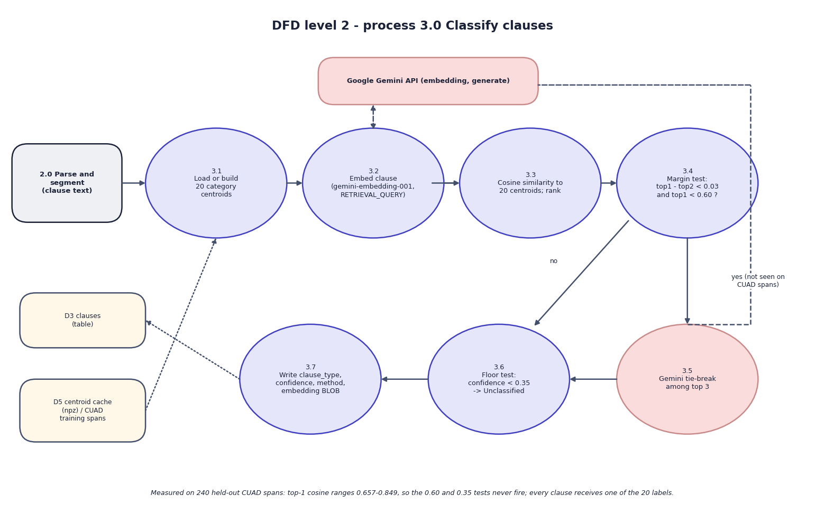
Fig. 5: Data-flow diagram, level 2: Classify clauses (process 3.0)
Process 3.0 expands into seven steps that follow classify_clause(). The 20 category centroids are loaded from the cache, or built from the 500 training spans if the cache is missing (3.1). The clause is embedded with the task type RETRIEVAL_QUERY through the Gemini API (3.2), and its cosine similarity to every centroid is computed and ranked (3.3). A margin test then asks whether the best two categories are within 0.03 of each other and the best similarity is below 0.60 (3.4). If so, Gemini is asked to choose among the top three categories (3.5); if not, the top category is kept. A floor test replaces the label by "Other / Unclassified" when the confidence is below 0.35 (3.6), and the label, confidence, method and embedding blob are written to the clause row (3.7).
The note under the figure records a measurement: on the 240 held-out CUAD spans the best similarity ranges from 0.657 to 0.849, so the 0.60 and 0.35 tests never fire and every clause receives one of the 20 labels (Chapter 6, section on the model, shows the distributions).

6 Use-Case Diagram
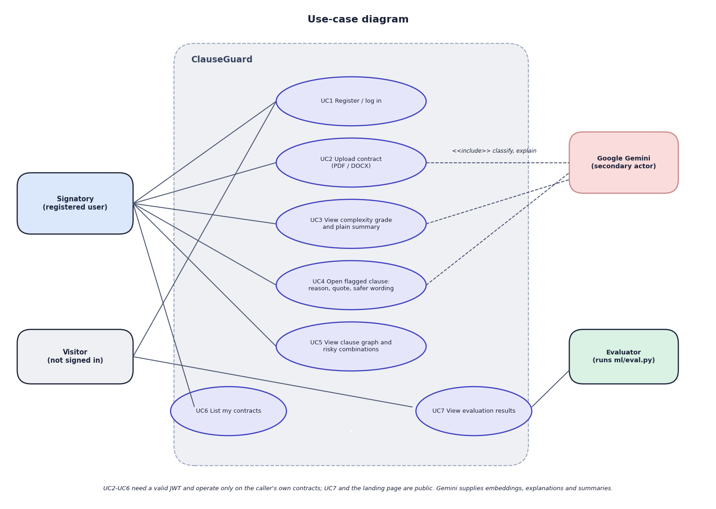
Fig. 6: Use-case diagram
Four actors appear. The signatory (a registered user) registers or logs in (UC1), uploads a contract (UC2), views the grade and plain summary (UC3), opens a flagged clause to read the reason, the quoted provision and the safer wording (UC4), views the clause graph and the risky combinations (UC5), and lists the contracts (UC6). The visitor, who is not signed in, can register or log in and can open the evaluation page (UC7), which is public. The evaluator runs ml/eval.py, which produces the figures that UC7 shows. Google Gemini is a secondary actor attached to the use cases that call it: uploading (classification and explanation), the summary and the clause explanation.
Use cases UC2 to UC6 need a valid token and work only on the caller's own contracts. There is no administrator role, no sharing between users and no way to edit or delete a contract in the interface.

7 Sequence Diagram
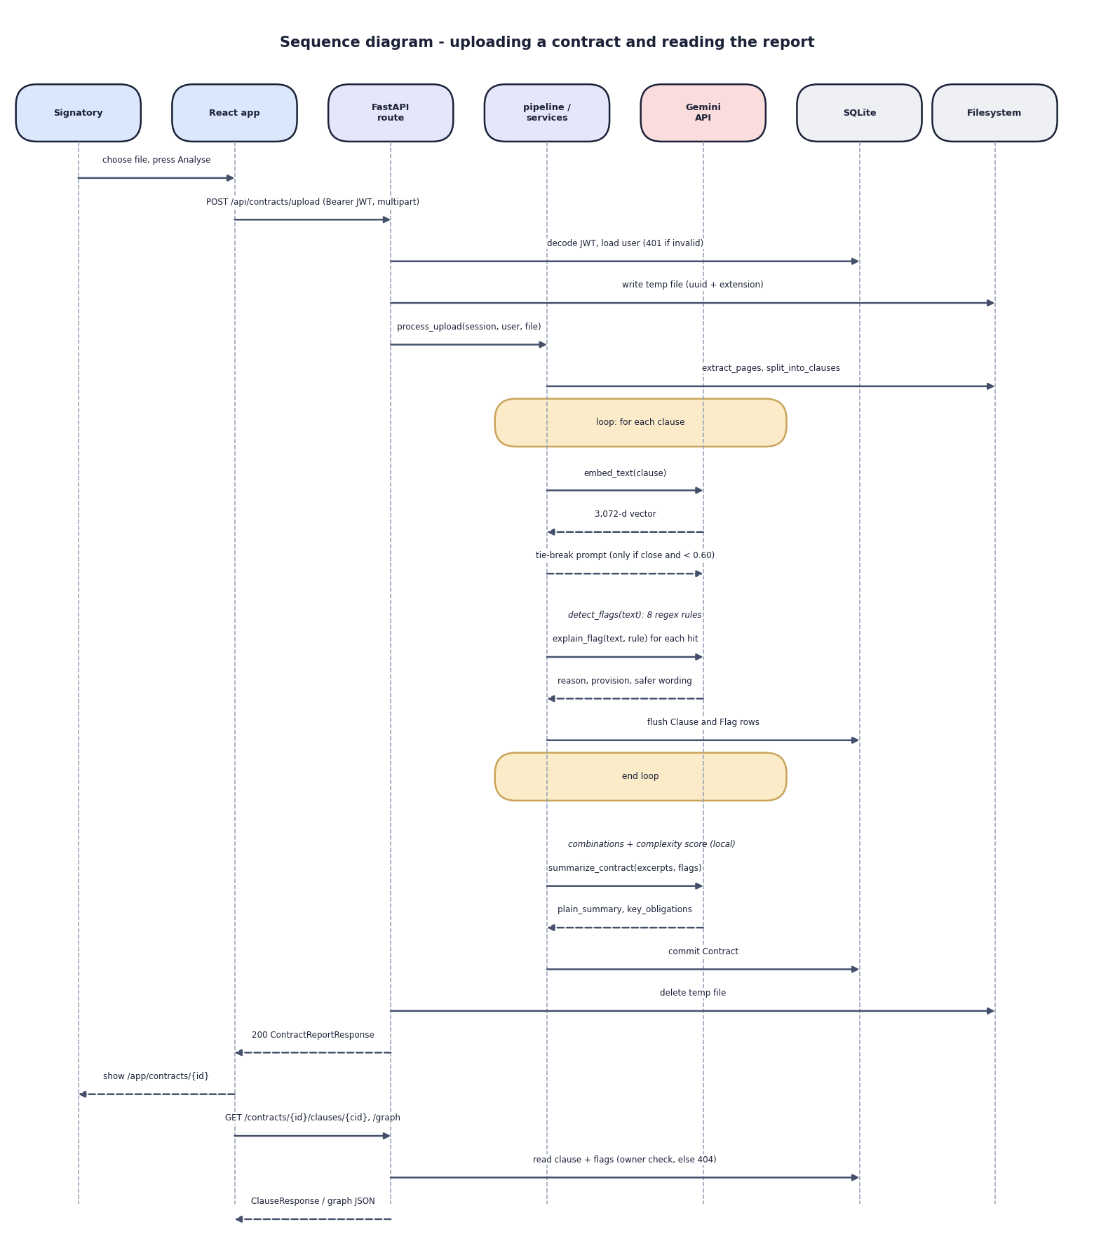
Fig. 7: Sequence diagram: uploading a contract and reading the report
The diagram follows one upload through seven participants. The user chooses a file and presses Analyse; the React app posts the multipart request with the bearer token; the route decodes the token and loads the user from SQLite (a bad token ends here with 401); the file is written under a random name and the pipeline is called. The pipeline reads the pages and splits them into clauses, then loops over the clauses: it requests the embedding from Gemini, sends a tie-break prompt only when the margin and similarity tests require it (which did not occur in the measured runs), applies the rules locally, requests an explanation for each hit and flushes the clause and flag rows. After the loop the combinations and the complexity score are computed locally, one more Gemini call returns the summary, and the contract is committed. The route deletes the temporary file and returns the report, the browser navigates to the report, and later requests for a clause or the graph read the rows again after the ownership check.
The sequence makes the cost visible: the number of Gemini calls is the number of clauses plus the number of flags plus one, and they run one after another. This is why the measured upload of an eleven-clause, eight-flag contract took 113.6 s and the fair eight-clause contract 15.5 s.

8 Entity-Relationship Diagram
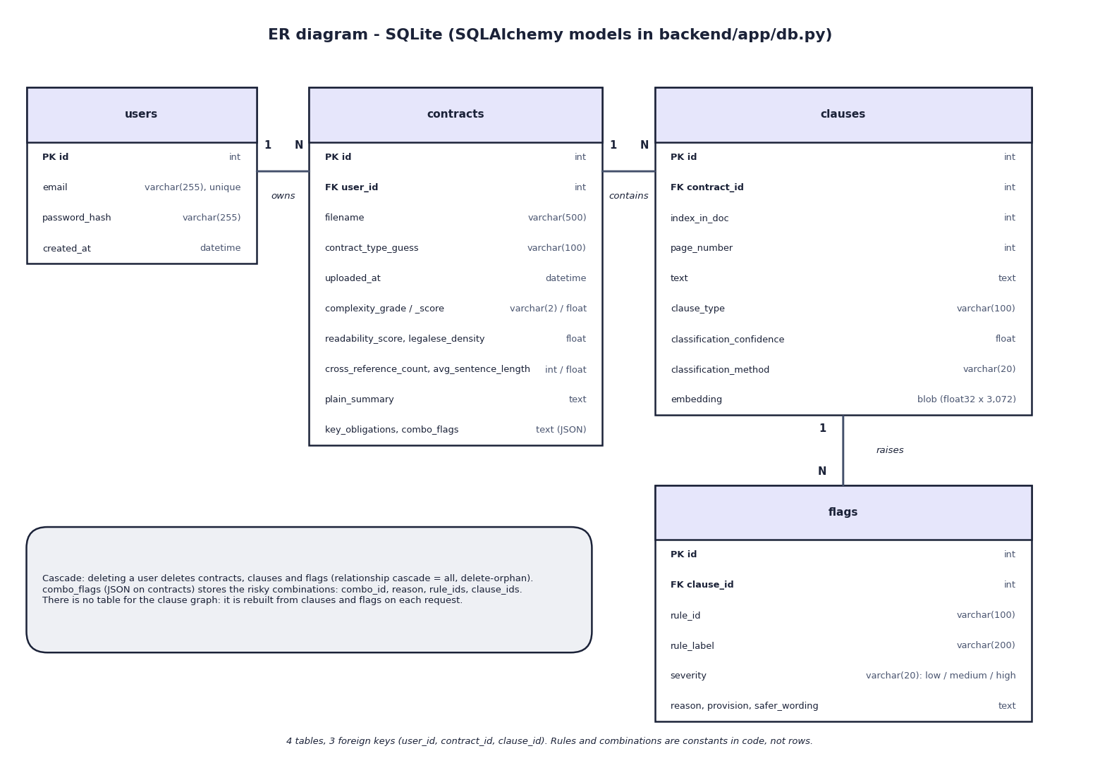
Fig. 8: Entity-relationship diagram
The database has four tables joined by three one-to-many relations: a user owns many contracts, a contract contains many clauses, and a clause raises many flags. The foreign keys are contracts.user_id, clauses.contract_id and flags.clause_id. The two JSON values of a contract (key_obligations and combo_flags) are stored as text columns, and the clause vector is a float32 blob of 3,072 values. The box in the figure notes that deleting a user cascades to everything below it through the SQLAlchemy relationships, and that the clause graph has no table because it is rebuilt from clauses and flags whenever it is requested.

9 UML Class Diagram
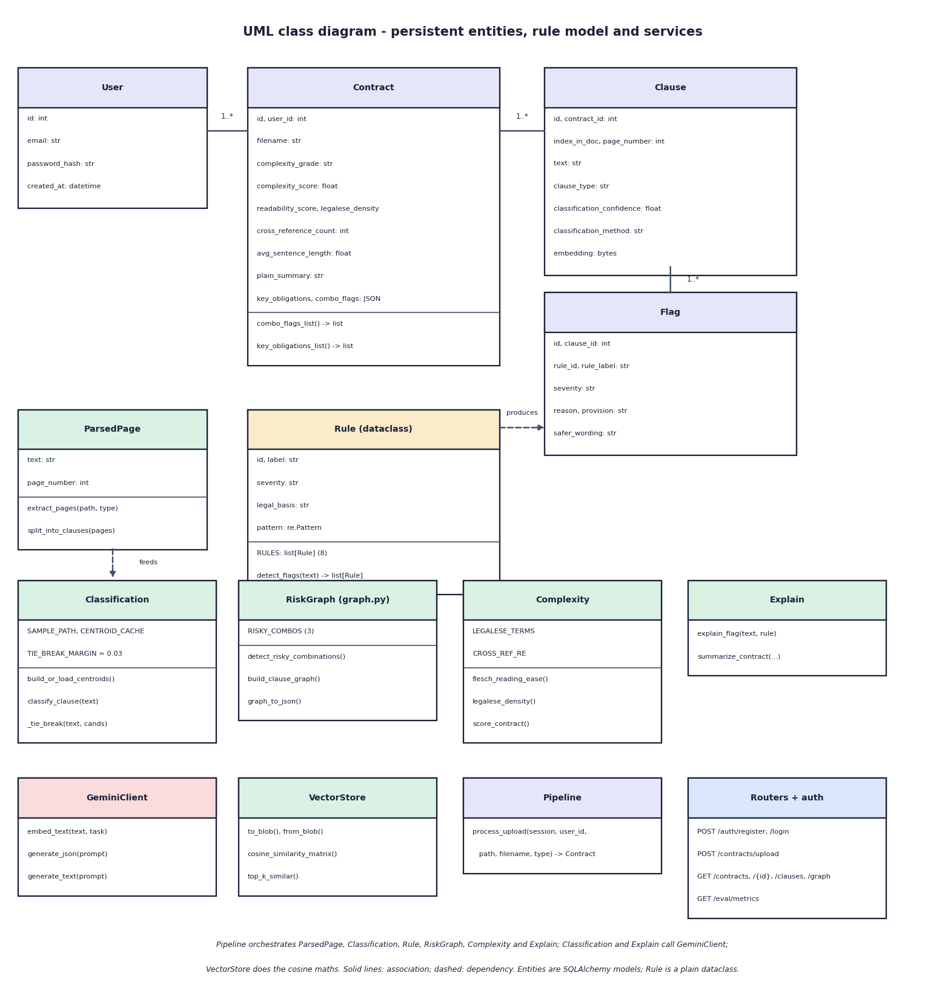
Fig. 9: UML class diagram
The upper part shows the four persistent entities (User, Contract, Clause and Flag) with their attributes and the 1..* associations, the Rule dataclass with its pattern and legal basis, and ParsedPage, the small value object that the parsing module passes to the segmenter. A Rule produces Flag rows; a ParsedPage feeds the classification service through the clause text. The lower part shows the services as classes of functions: Classification, RiskGraph, Complexity, Explain, GeminiClient, VectorStore, Pipeline and the routers with the authentication helpers. Pipeline coordinates the others; Classification and Explain use GeminiClient; VectorStore does the cosine arithmetic. The service modules are plain Python modules, so the diagram shows them as classes only to make their operations visible.

10 Flowcharts of the Core Algorithms
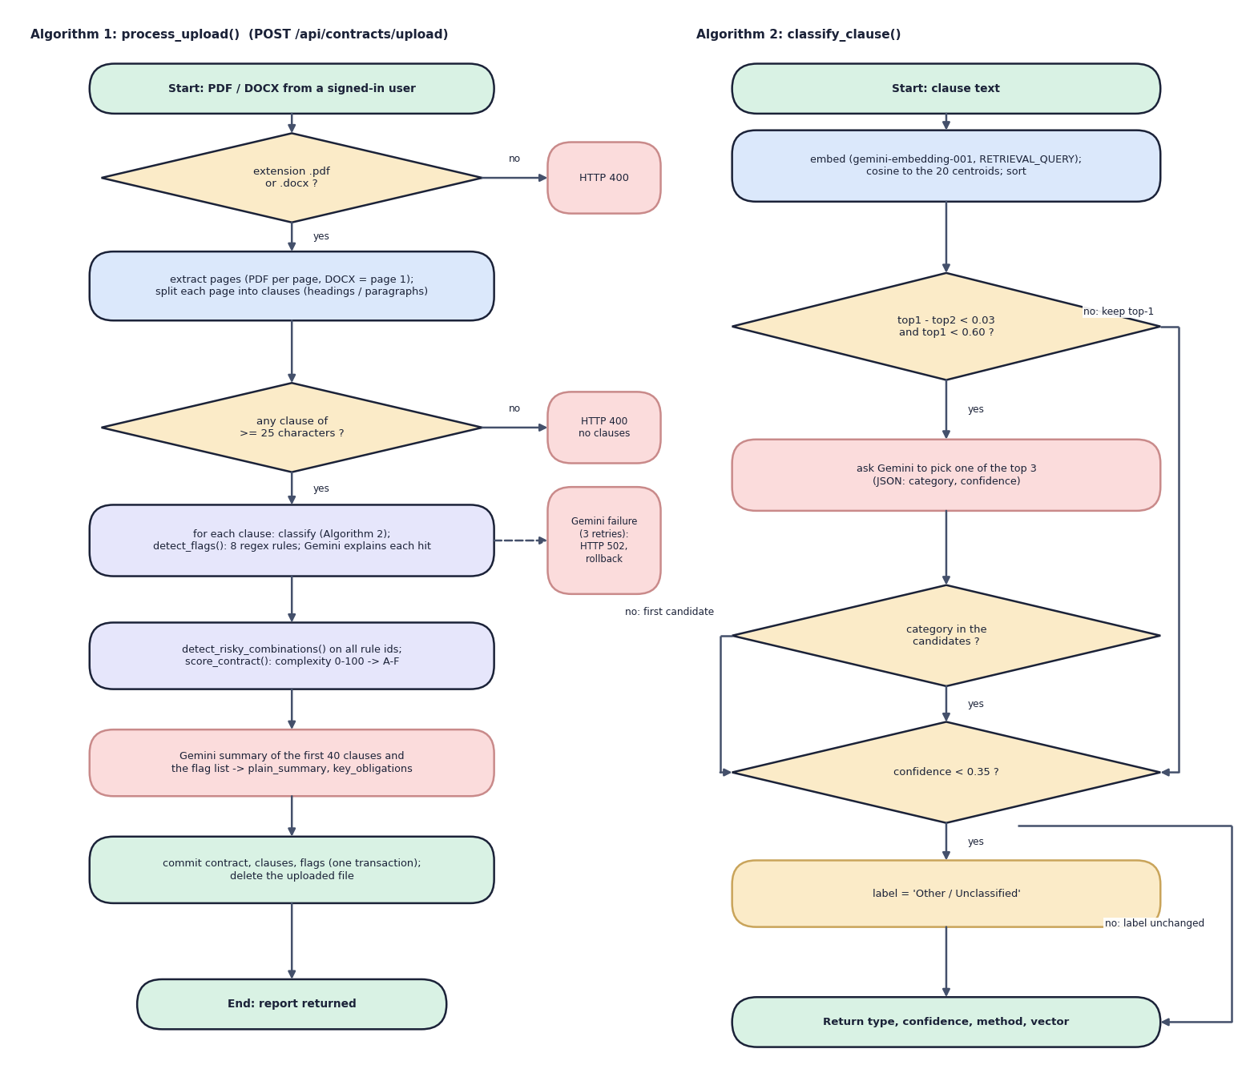
Fig. 10: Flowchart of the core algorithms
Algorithm 1 is process_upload(). The extension must be .pdf or .docx (otherwise HTTP 400); the pages are extracted and split, and at least one clause of 25 or more characters must remain (otherwise HTTP 400 "no readable clauses"). For every clause the pipeline classifies, applies the eight rules and asks Gemini to explain each hit; a Gemini failure after three retries raises an error that the route reports as HTTP 502 and the transaction is rolled back. After the loop come the combinations, the complexity score, the summary and one commit.
Algorithm 2 is classify_clause(). The clause is embedded and ranked against the 20 centroids. If the best two categories differ by less than 0.03 and the best similarity is below 0.60, Gemini chooses among the top three; an answer outside the candidates falls back to the first candidate with the embedding similarity as its confidence. Finally, a confidence below 0.35 changes the label to "Other / Unclassified". The result carries the label, the confidence, the method (embedding or gemini_tiebreak) and the vector.

